AGOL and Portal Backup Script User Manual

This document is for end users who do not need to understand how the script runs but would like to get their data on an automated backup. It is extracted from the YOSE EGIS User Manual. Some path files have been changed for generalization.

**Backing Up Hosted Feature Layers**[**ℑ**](http://gis.yose.nps.gov/help/user/AGOLAndPortal/EGIS_JSONBackup.html#backing-up-hosted-feature-layers)

If you own hosted feature layers in ArcGIS Online (AGOL) or GIS Portal, you are responsible for backing up your data. If your data in AGOL or Portal is accidentally overwritten, improperly edited, deleted when it should not have been, or for some reason inaccessible on the platform, there is no way to restore it unless you take steps to create backups.

This page describes how to have your hosted feature layers automatically backed up as well as how to back up AGOL or Portal data manually.

**Automated Backup**[**ℑ**](http://gis.yose.nps.gov/help/user/AGOLAndPortal/EGIS_JSONBackup.html#automated-backup)

Yosemite EGIS has established an automated backup routine where hosted feature layers shared with specific AGOL or Portal “Data Backup” groups are backed up daily. Anyone may include their data in these automated backups and when participating, retrieve their backed up data themselves on the GIS Workspace if they need it.

Yosemite has many AGOL and Portal publishers, so this is an enterprise (parkwide) solution to mitigate loss in hosted feature layers in use across Yosemite.

**What Gets Backed Up**[**ℑ**](http://gis.yose.nps.gov/help/user/AGOLAndPortal/EGIS_JSONBackup.html#what-gets-backed-up)

The automated backup is only for hosted feature layers, not web maps, apps, surveys, or other types of content.

* Backups are saved as JSON files in AGOL_PORTAL_Backups. JSON files preserve data records and schema, including domains, but not attachments.
* Attachments are NOT backed up, as this could significantly impact both file storage on the GIS server and how long it takes the automated backup to run. To back up attachments see the [Manual Backups](http://gis.yose.nps.gov/help/user/AGOLAndPortal/EGIS_JSONBackup.html#manualbackuphosted) section.
* Sensitive data can be included. Data backups from Portal are saved in protected subfolders to restrict access.
* Nothing further is done with the JSON file backups unless a GIS user needs to recover data. A tool is provided in the Yosemite Custom Toolbox in \\inpyosegis\Yosemite_EGIS\Tools to extract a JSON to a file geodatabase and instructions are provided below.

**How to Include Hosted Feature Layers in the Automated Backup**[**ℑ**](http://gis.yose.nps.gov/help/user/AGOLAndPortal/EGIS_JSONBackup.html#how-to-include-hosted-feature-layers-in-the-automated-backup)

The automated backup is intended for hosted feature layers **that are actively being edited**, i.e. mobile data collection projects and dashboards. Static layers do not need to be backed up daily. Follow the steps below to include your hosted feature layers in the automated backup.

* Talk to your GIS coordinator about whether they already manage a Data Backup group. If they do not, work with [YOSE_GIS_support@nps.gov](mailto:YOSE_GIS_support%40nps.gov) to establish a YOSE Data Backup group or add an existing group to the automated backup routine.
* Share your hosted feature layers that need to be backed up with the Data Backup group.
* Let the script run overnight. Then check the logs in \\inpyosegis\Yosemite_EGIS\GIS_Workspace\Backups\AGOL_PORTAL_Backups\LOGS. Your layers should be included in the log and flagged as successfully downloaded. If they are not, email [YOSE_GIS_support@nps.gov](mailto:YOSE_GIS_support%40nps.gov).

**How to Extract Data from the Automated Backup**[**ℑ**](http://gis.yose.nps.gov/help/user/AGOLAndPortal/EGIS_JSONBackup.html#how-to-extract-data-from-the-automated-backup)

Is Portal down? Did some records get deleted that you didn’t want deleted? Time to extract the backup!

Open a new or existing ArcGIS Pro Project. In the Catalog Pane navigate to \\inpyosegis\Yosemite_EGIS\Tools and expand the Yosemite Customs Tools.tbx. Open the Enterprise Data Management Toolbox and click on the Extract JSONs Tool.

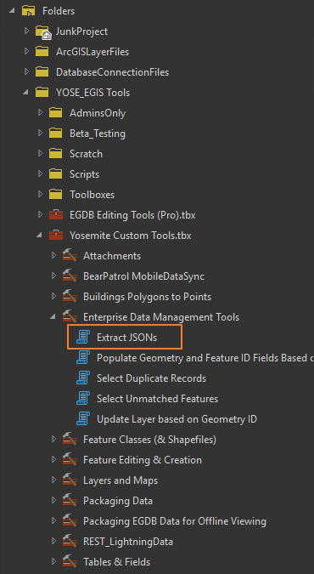

The first parameter in the tool is the zipped file containing the JSON to extract. Click on the folder next to the input to open a file explorer window. Navigate to the folder in \\inpyosegis\Yosemite_EGIS\GIS_Workspace\Backups\AGOL_PORTAL_Backups where your data is saved.

**Hint**

Backups are organized by platform: ArcGIS Online data goes into the AGOL folder, GIS Portal data goes into the Portal folder. Each Data Backup group has an associated folder within the platform folder where their backups are stored. Backups are stored as a single zipped folder [platform]_download_[YYYYMMDD]_[HHMM].zip. Within the zipped files are JSONs for every item shared to that group. Consider which zipped file will contain the most recent correct copy of your data when you selected the parameter.

The second parameter is a geodatabase where the extracted feature classes should land. It automatically populates with the Project’s default geodatabase, but any workspace can be used by clicking on the folder next to the parameter input.

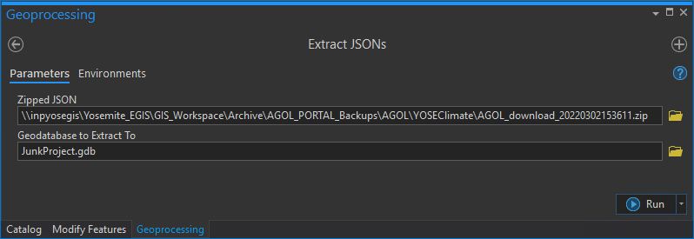

Click the run button. When the status bar turns green the script has finished and your data should be extracted into the specified geodatabase.

**Note**

The tool will take a long time (>5 minutes) to run if your dataset contains a lot of picklists.

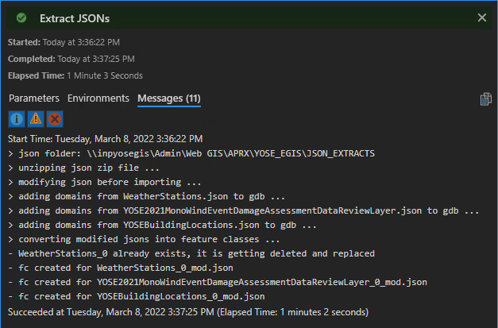

Pull the data into the Pro Project map and review it to make sure it looks as expected.

**Important**

If you rerun the tool with the same or a different zipped backup and specify the same geodatabase, the script will overwrite any existing datasets with the extracted data. If you need to compare several days worth of edits, you need to rename the feature classes between each run or extract to different geodatabases.

**Manual Backup**[**ℑ**](http://gis.yose.nps.gov/help/user/AGOLAndPortal/EGIS_JSONBackup.html#manual-backup)

AGOL or Portal provides a manual method for creating backups through your web browser.

To create a manual backup, **Export Data** from the item page of your hosted feature layer in AGOL or Portal.

**Export to FGDB** (file geodatabase) is recommended and is also the only format that will include attachments.

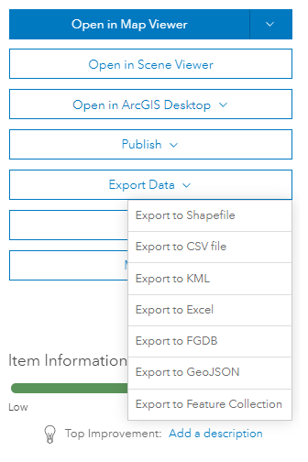

**Hint**

A tag is required when you export data. Use the tag “export” or “backup.”

Consider using a naming scheme with YYYYMMDD and optionally HHMM to clearly note the date and time of the backup.

Alternately, add your hosted feature layer to your ArcGIS Pro Project. Then right-click the layer from the Contents pane and select Data > Export Features to manually save backup copies of your online data. (If any records are selected, exporting features from ArcGIS Pro will only export the selected features.)